Components of LangChain
​It consists of several components – Documents, Chains, Agents, Language Model, Chat Model, ​Chat Message, Prompt Templates, and Output Parsers. ​In this, you'll review the Language Model, Chat Model, Chat Message, Prompt Templates, ​and Output Parsers of LangChain.

- Language Model - ​The Language Models in LangChain are the foundation of LLMs. ​It uses text input to generate text output and helps complete tasks and summarize documents. ​LangChain uses IBM, OpenAI, Google, and Meta as a primary language model. Example:
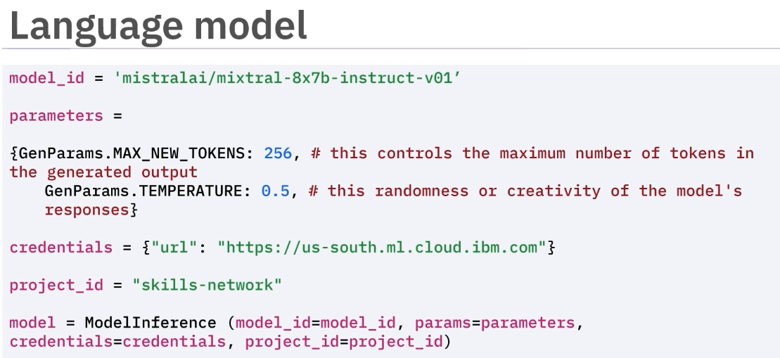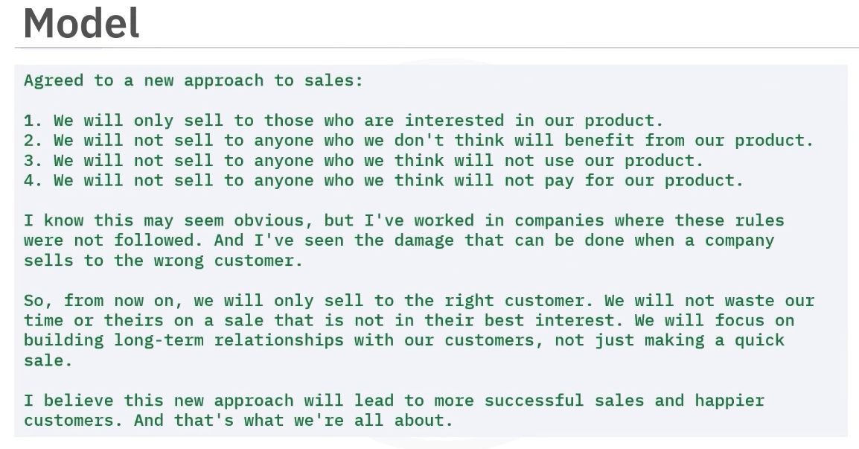(Model generated output)
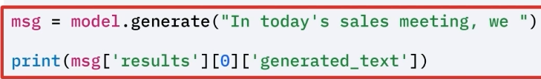

- Chat Model – A chat model is defined for efficient conversations. It means that it understands the question or prompts like a human. Next, to generate a response, first create a language model using WatsonX.AI and transform ​the model into a chat model using WatsonX's LLM function. ​This converts the chat model into a conversational LLM to engage in dialogues.
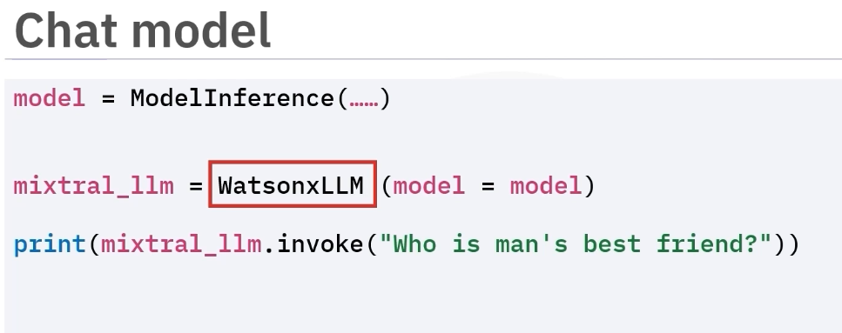

- Chat Message –
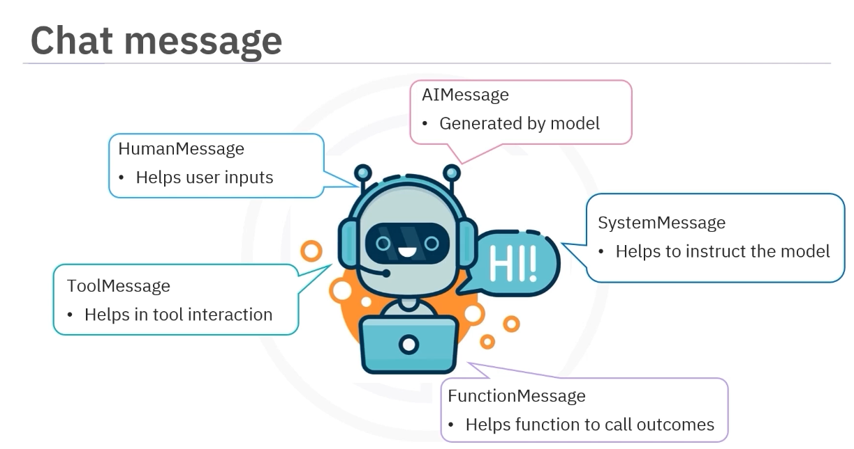
In the chat message, each chat message consists of two key properties. ​The role means who is speaking and the content means what is being said.

Look at the example of a system-generated message, in which the model has given instructions ​to be an AI bot to respond to the question, What to eat in one short sentence.
​To respond to this question, the chat model creates a list of messages. ​First, configure the model as a fitness activity bot using a system message. ​Then simulate the past conversation using human message and AI message. ​Next, using these settings, the model generates responses based on the previous dialogue.
These messages give the model context so it can answer the next question properly.
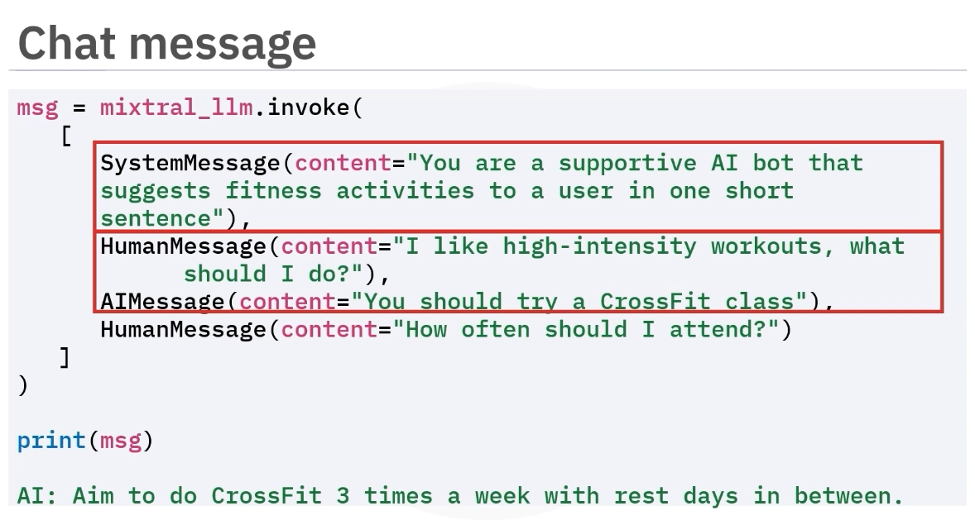

- Prompt Template - ​The prompt templates in LangChain translate the user's questions or messages into clear ​instructions. ​The language model uses these instructions to generate appropriate and coherent responses. ​The types of prompt templates are: A) String prompt templates is useful for single-string ​formatting. B) ChatPrompt Template is useful for message lists. C) MessagePromptTemplate includes AI Message Prompt Template, System Message Prompt Template, Human ​Message Prompt Template, and Chat Message Prompt Template allows flexible role assignment. ​The Messages placeholder provides full control over message rendering. ​And D) Few Shot Prompt Template provides specific examples or shots for LLMs.

1. StringPromptTemplate
StringPromptTemplate generates a plain text prompt (string).

3. MessagePromptTemplate
A MessagePromptTemplate creates one message inside a chat prompt.
It is basically a template for a single message.
Example:
HumanMessagePromptTemplate
SystemMessagePromptTemplate
AIMessagePromptTemplate
Example:
from langchain_core.prompts import HumanMessagePromptTemplate
template = HumanMessagePromptTemplate.from_template(
"Explain {topic}"
)
Input:
topic = "gravity"
Output:
HumanMessage("Explain gravity")
So it produces one chat message.

2. ChatPromptTemplate
ChatPromptTemplate generates a list of chat messages instead of one string.
It is used with Chat Models.
Example:
from langchain_core.prompts import ChatPromptTemplate
prompt = ChatPromptTemplate.from_messages([
("system", "You are a helpful assistant"),
("human", "Explain {topic} simply")
])
Input:
prompt.invoke({"topic": "black holes"})
Output internally becomes:
[
SystemMessage("You are a helpful assistant"),
HumanMessage("Explain black holes simply")
]
Then the chat model processes it.

Key idea
ChatPromptTemplate
↓
List of messages
↓
Chat Model

It is used with Language Models (LLMs) that accept text input.
Example concept:
template = "Explain {topic} in simple terms"
Fill variables:
prompt.format(topic="black holes")
Output:
Explain black holes in simple terms
So the model receives:
"Explain black holes in simple terms"

Key idea
StringPromptTemplate
↓
Plain text prompt
↓
Language Model
Typical class built on it:
PromptTemplate

1. Prompt Templates Are Model-Independent
Classes like:
- PromptTemplate
- ChatPromptTemplate
- HumanMessagePromptTemplate
come from LangChain core, not from any model provider.
Example:
from langchain_core.prompts import ChatPromptTemplate
This works because a prompt template is just formatting text/messages.
It doesn’t know or care which model will be used.

2. Model Providers Are Separate
When you actually run the prompt with a model, then you import the provider.
Example with OpenAI:
from langchain_openai import ChatOpenAI
This is needed because the model is hosted by OpenAI.

3. How They Work Together
Typical LangChain code looks like this:
from langchain_core.prompts import ChatPromptTemplate
from langchain_openai import ChatOpenAI
prompt = ChatPromptTemplate.from_messages([
("system", "You are a helpful assistant"),
("human", "{question}")
])
model = ChatOpenAI()
chain = prompt | model
chain.invoke({"question": "Explain gravity"})
Here:
PromptTemplate → builds messages
ChatOpenAI → generates response

- OutputParser - The Output Parsers transform the output of an LLM into a more suitable format for generating ​structured data. ​The LangChain provides a library of Output Parsers for various data formats including ​JSON, XML, CSV, and Panda DataFrames. ​Output Parsers allow you to tailor the model's output to meet specific data handling needs. ​For example, let's use Comma Separated List Output Parser to convert LLM's response ​into CSV format.
